 | Basic American Enterprises LLC  7076 Island Village Dr, Long Beach, CA 90803  310.488.7205  www.basicamericannetworks.com

Adding a Second Cooling Unit to Two Outdoor Fiber Cabinets
ADTRAN MiniOLT and Nokia / Google Fiber Compact Cabinet | Concept report, plain-language edition | 8 October 2026
Goal: keep each cabinet's existing cooling unit working, and add a second one on a different door or panel.

Summary
Item | Plan
ADTRAN cabinet | Leave the current cooling unit on its door. Put the new unit on the opposite door, using a custom-built sealed door. Have it stick out from the cabinet as much as possible, to save space inside.
Nokia cabinet | Leave the current cooling unit where it is. Replace the smaller, empty door or panel with a new one that holds the second unit.
Heat from the equipment | 1,000 watts today + 500 watts planned = 1,500 watts per cabinet. That is about the heat of a space heater on high, running all the time. To be confirmed on site.
Goal | Make the cabinet 10°C (18°F) cooler. We still need to define: cooler than what, measured where, and on how hot a day.
Status | Early concept, not a final design or a manufacturer's guarantee.
The one thing everyone must understand
These cooling units work like a radiator, not an air conditioner. They move heat from inside the cabinet to the outside air. That means:
- They can never make the cabinet cooler than the outdoor air. On a 40°C (104°F) day, the inside will be at least 40°C.
- A unit labeled "1,500 watts" does not guarantee 10°C of cooling. How well it works depends on how much hotter the inside is than the outside, plus sun beating on the cabinet, air leaks, and blocked airflow.
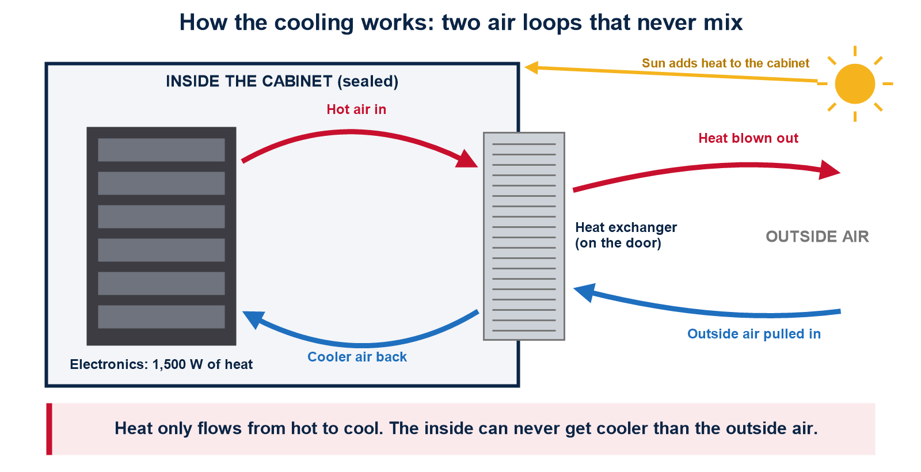

How it has to work
- Two separate air loops: inside air stays inside, outside air stays outside. They never mix, so dust and moisture stay out.
- The cabinet must stay weather-sealed.
- Technicians must still be able to open the doors and reach the equipment.
- Don't let hot air loop back: if the hot air blowing out gets sucked right back in, the unit cools nothing.
- Check that the doors, hinges, latches and seals can handle the extra weight. Also plan for power, controls, drainage and rain.
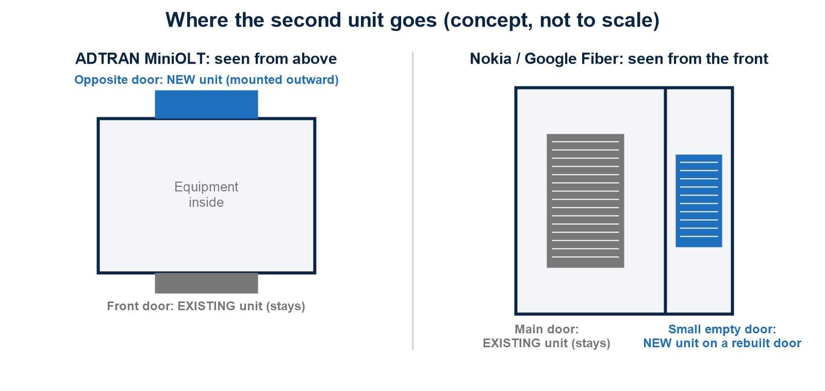

ADTRAN cabinet: the opposite-door plan
Putting the new unit on the opposite door, rather than next to the old one, uses the space better and cools the cabinet more evenly from both sides. If the door opening is too small or the unit too heavy, build a new reinforced, sealed door.
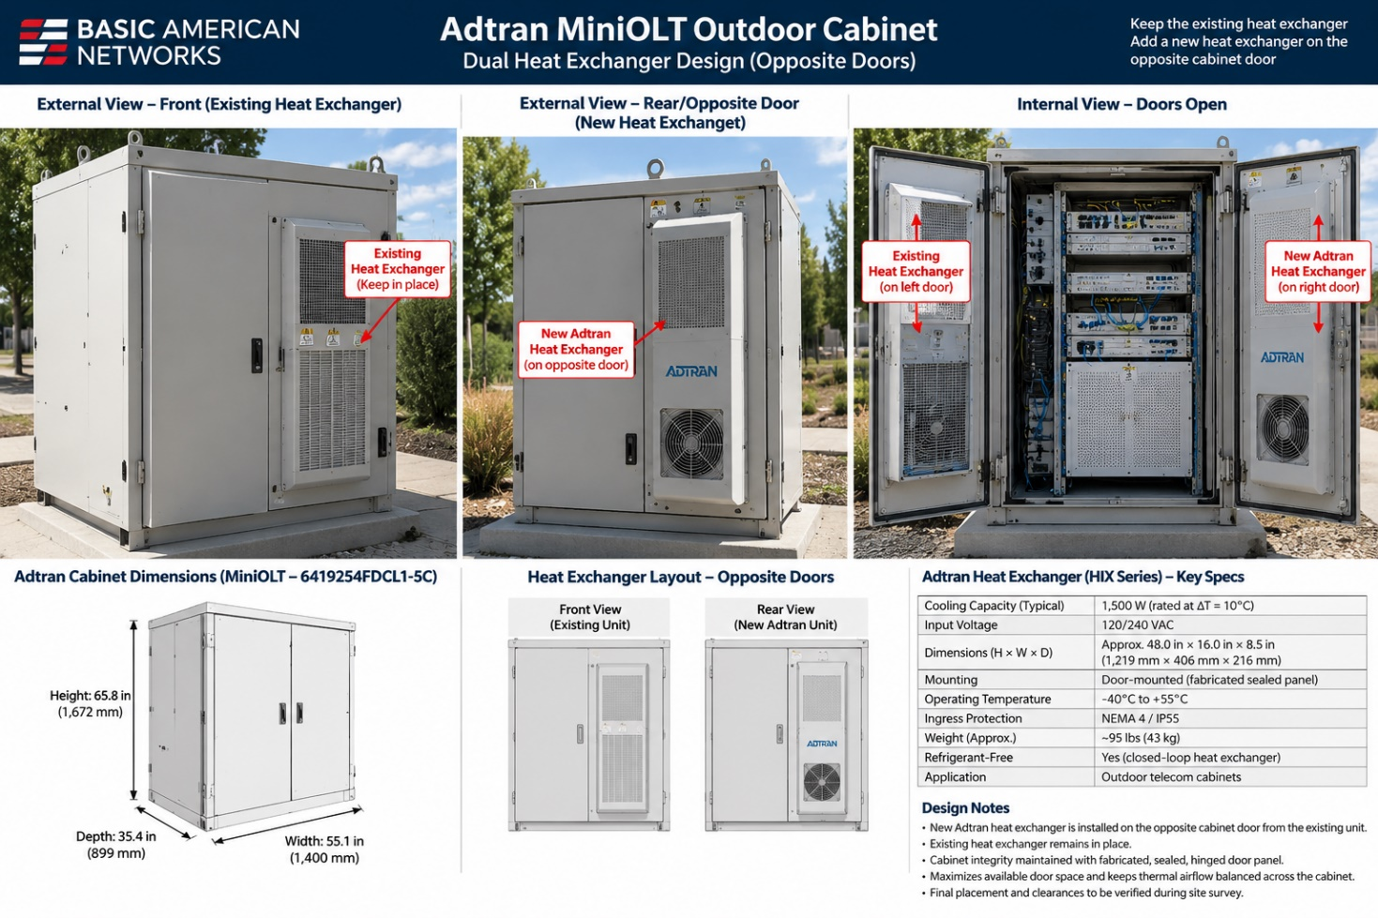
Concept illustration only. The sizes and ratings shown in the picture are not confirmed and must not be used for ordering parts or building.
To check on site: the exact cabinet model; measurements of both doors, the openings and the hinges; how far the doors swing; weight and balance; wind load; whether the door can hold the bolts; clearance for cables and fans; and whether the new door seals as tightly as the original.

Nokia cabinet: the small-door plan
Keep the old unit running. Mount the new one on a rebuilt, reinforced, sealed version of the smaller empty door, extended outward as far as is safe and practical. Don't assume ADTRAN measurements apply here; it is a different cabinet.
Element | Plan
Original door or panel | Existing cooling unit stays as is. Confirm exactly where it is, how air flows through it, and its model.
Smaller empty door or panel | Holds the second cooling unit, on a newly built replacement door or panel.
Sticking out | Mount it as far outside as possible, to protect the equipment and cables inside.
Airflow | Hot air blowing out must not be pulled back in, and hot air inside must actually pass through the unit.
Still unknown | Door size, how far the unit can stick into the cabinet, hinge strength, locks and latches, the power supply, and the exact specs of the existing unit.

The heat math, simply
The same 1,500-watt case applies to both cabinets.
Question | Answer
How much heat does the equipment make? | 1,500 watts, about 5,100 BTU per hour (the same unit used for home air conditioners). The sun adds more.
What must the cooling handle? | Equipment heat + sun + any other heat, minus what escapes through the cabinet walls.
How much cooling is needed for a 10°C drop? | The two units together must move 150 watts for every degree the inside is hotter than the outside, before counting the sun.
Can two units do it? | Old unit + new unit must handle the total heat on the hottest design day, with room to spare.
How much air must move? | About 263 cubic feet per minute to carry away 1,500 watts with a 10°C rise, roughly three strong bathroom fans. An example, not a spec.
The limit | The inside must be hotter than outside for heat to flow out.

What is confirmed, and what isn't
Item | Status
ADTRAN cabinet (model 6419254FDCL1-5C) | Sizes, door opening, existing unit's label: NOT CONFIRMED
Nokia cabinet | Model, sizes, existing unit's label: NOT CONFIRMED
New cooling unit (HIX/HTX type) | Brand, part number, performance, voltage, weight, size: NOT CONFIRMED
How the unit is rated | Check whether it is rated "watts per degree" or "watts at a set temperature." They are not the same. Mixing them up is a common, costly mistake.
Power | Voltage, power draw, startup surge, thermostat, alarms, grounding, shutoff switch.
Weather | Weather rating, temperature range, rust protection, filters, rain protection.
Structure | Added weight, wind and earthquake loads, hinge strength, reinforcement, seal pressure, door swing.

Next steps
- Visit both cabinet types. Measure and photograph the doors, equipment and the labels on the existing units.
- Get the official drawings from the cabinet makers, and the install and performance sheets from the cooling unit maker.
- Define the goal: the hottest outdoor temperature to design for, how much sun hits the cabinet, where the hot spots are, and exactly what "10°C cooler" means.
- Run the numbers with the real performance of both units at 1,500 watts plus the sun.
- Build one test door for each cabinet type. Check that it opens, closes, seals and leaves room to work.
- Test it in real conditions: temperature sensors outside, inside and on the hottest equipment, through a hot, sunny, full-load period.
- Only after the test passes, release the final parts list, drawings and wiring plans.
Bottom line
Every size, model and cooling number in this report still has to be confirmed from official documents or measured on site. The pictures are concepts, not blueprints.
Prepared for design discussion | 8 October 2026

